**Annoucement to students applied to**

**Field Course in Regional Geology MG421T24E**

The regional geology course for students of geology (part crystallinicum and folded Paleozoic Cover (MG421T24E) will take place from Wednesday 21 th May 2025 to Friday 23 th May 2025. The excursion to the platform cover is organized by Prof. Opluštil independently (Please to contac him). The course will take place in the form of star-like excursions from Prague by means of public transport (train for first two days of excursion, bus for the 3th day) with every day return to Prague).

We would be probably able to buy some refrischment and drinks, but i tis better to take some own meal and drinking water, because shops and restaurants on the route could have a closing day.

The field course will be devoted to the geology of the Bohemian Massif and to geology of the Barrandian Neoproterozoic. Fist two days excursion will be devoted to contact of the Kutna Hora Crystalline Unit, Moldanubicum and Teplá_Barrandian Block in the Sázava River valley section between Český Šternberk and Stříbrná Skalice.

Third day, the excursion program will be devoted to Neoproterozoic geology of the NE flank of the Teplá-Barrandian Unit. The island arc rocks of Ediacarian age will be shown in the Vltava River incised valley (from the Slapy dam to Štěchovice south of Prague). Intrusives of the CBPC intruding into Neoproterozoic basement will be also presented.

**Field excursion to the Crystalline complexes of the Bohemian Massif (21.5. -234.5. 2025)**

**Day 1 (21. 5. – 22. 5. 2025, Wednesday)**

**Tectonic contact of Moldanubian Unit in the Sázava valley between Č. Šternberk and Ledečko, ,**

Departure: **Wednesday 21. 5. 2025** – railway station Vršovice (see picture below, station is marked by red star) or 5-8 min earlier from the Prague main station (aprox. 10 minutes from the Albertov by tram no. 18, 24, 7). Passenger train from Prague to Benešov no 2513. Departure from Praha Vršovice at 6:26, arrival Čerčany 7:13 pass to bus 9209, departure 7:29 to Čerčany (arrival at 7:13, pass to pass. train to Český Šternberk. , departure from Čerčany 7:29, arrival to the Český Šternberk (8:30) (ticket price 152 Kč (price without any discount).

Back by bus from the village Ledečko n. Sázavou (train S80 OS 92), departure at 15:11 to Čerčany, station, , arrival at 15:59, pass to train departing to Prague at 16:13, arrival to Prague Vršovice 17:00 (Prague main station 5 minutes late). (ticket price 144 (without any discount) Kč without student discount). You can try to get a student discount (if you have a Prague travel card) – It is possible to buy a ticket from the outer traffic zone).

**Day 2**. **Thuersday 22.5. 2025 – contact of the Kutná Hora Crystalline Complex with Moldanubicum and Central Bohemian Plutonic Complex)**

The second day the transport is the same way (departure at 6:26 form the train station Praha Vršovice, pass in Čerčany and we arrive at ca 8:12 to Samopše. The we walk to village Stříbrná Skalice (ca 15 km). Back from the Stříbrná Skalice train stop at 15:30, arrival to Čerčany is 15:59, pass to train to Prague (departure 16:13), arrival to Prague Vršovice is 17:00 (or a hour later in case we arrive a hour later from Stříbrná Skalice) Assumed price for one way ticket (without discount) is about 130 and back 122 CZK (for the second day 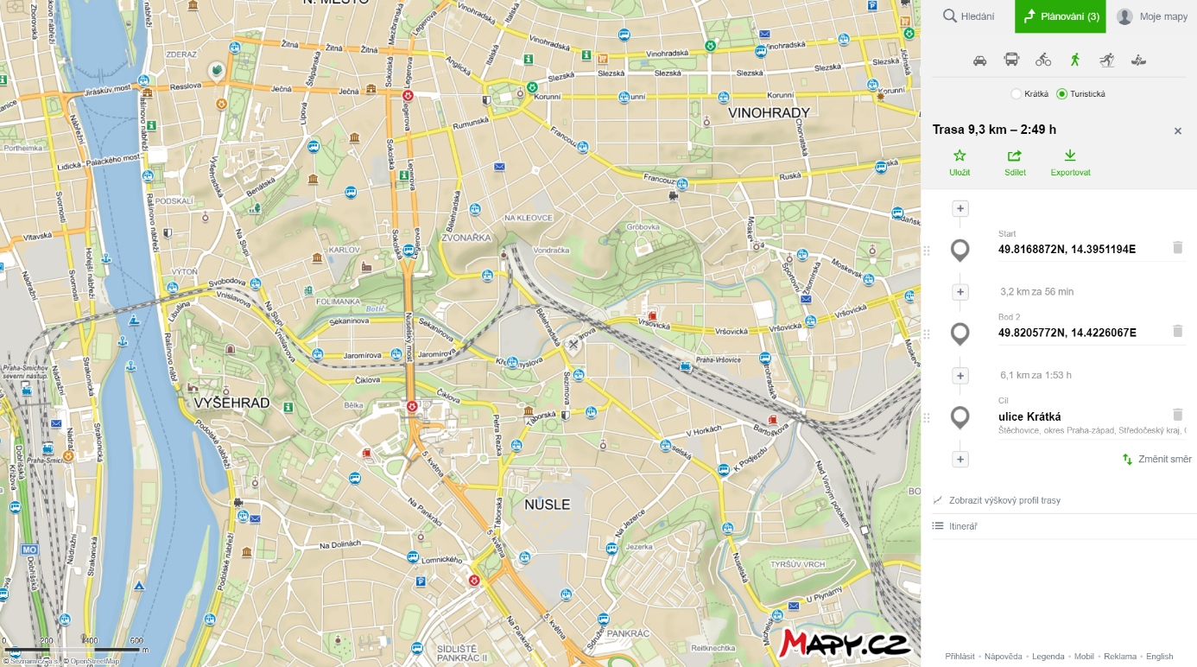

**Day 3**: (**Friday 23. 5. 2025**) – **Ediacarian island island arc developed on the NE flank of the Teplá-Barrandian Unit (volcanics, subvolcanics and volcanoclastics of the Jílové Belt, Neoproterozoic to Cambrian Flysh of the Štěchovice G., Variscan Central Bohemian Plutonic Complex)**

Meeting point (viz a map below). Stop in front of the entrance to the Prague Smíchov Railway Station (see map) at 7:15, bus number 361– here are bus stops (direction, Štěchovice, Slapy, Motorest).

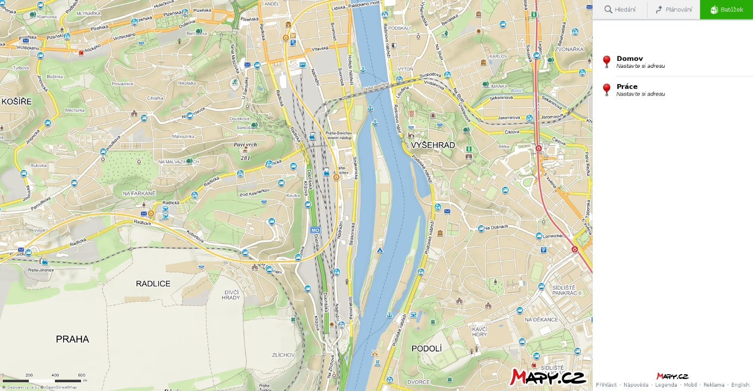

Meeting point

Departure of bus **No 361 at 7:20** am, arrival Slapy Motorest 8:06 (price ca 60 CZK without discount). Ca 13 km walk along the Vltava River valley from Slapy to Štěchovice village).

Expected return - 16 - 17:00 - back by bus from Štěchovice, frequency of the busses are aprox. 0,5 hour, for example departure from Štěchovice (Bus N 360 at 15:10 - 16:18 (arrival to the Prague-Smíchov-railway station).

From Slapy village to Štěchovice walk along the road, then a hiking trail around the Štěchovice dam in the Vltava valley.

On field trips it is necessary to take off-road shoes and clothes, backpack, raincoat, notepad, stationery, camera). Each participant will be required to have a geological hammer. Who has a geol. compass, take with you! It is necessary to take sufficient money to cover the costs of food and transport. Students who do not own a geol. compass, the compasses will be lent.

More detailed descriptions of excursion sites, rock micrographs, publications on the above issues can be downloaded from the UGP web site at:

<http://web.natur.cuni.cz/ugp/main/staff/kachlik/>

or in the university moodle web page:

<https://dl2.cuni.cz/course/view.php?id=2800>

Conditions for obtaining the credit (for foreign participants the conditions for obtaining the credit will be specified during the excursion). The only field trip protocols will be checked on the end of excursion.

List of the suggested literature is included in above mentioned websites.

V. Kachlík.